**EXTRA SUPPLEMENT MATERIAL FOR LAB 4**

The purpose of this Lab Extra Material is to make your lab experience smoother.

After going through the lab-4 handout please do watch the following video;

<https://drive.google.com/file/d/1vBmvLss6gpJ-J4nzH6ooPNBlVi0d1Grs/view?ts=617fb412>

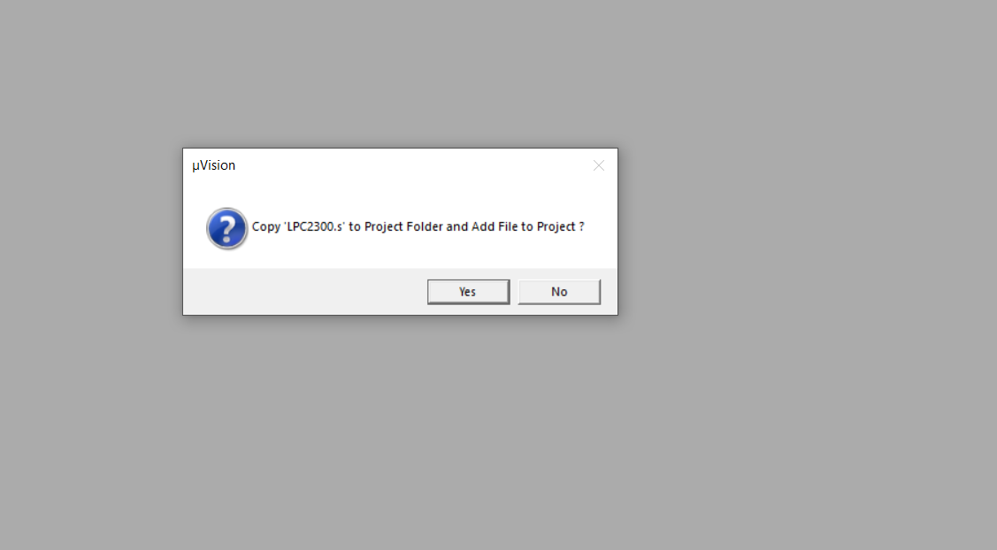

While creating project in Keil, Do not forget to click Yes. It is needed and mandatory when we are writing in C

The following content is from LPC23xx Manual that is shared with you. As it is difficult for you to look into the entire manual, we are sharing the important tables here. Please look into the manual for additional information.

**Pin Function Select register 0 (PINSEL0 - 0xE002 C000):**

The PINSEL0 register controls the functions of the pins. The direction control bit in the IO0DIR register (or the FIO0DIR register if the enhanced GPIO function is selected for port 0) is effective only when the GPIO function is selected for a pin. For other functions, the direction is controlled automatically

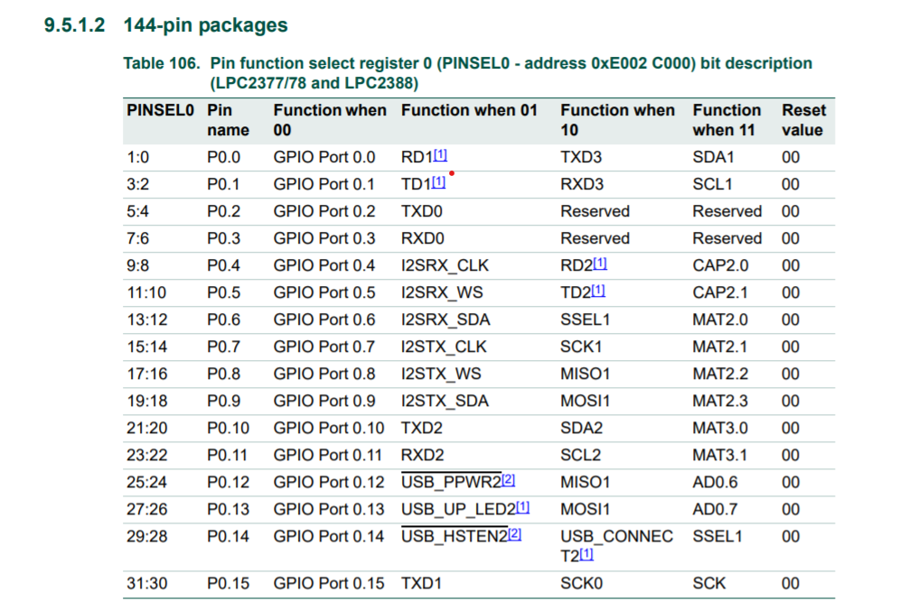

**Chapter 10 of LPC23XX Manual (especially from Page 170-180)**

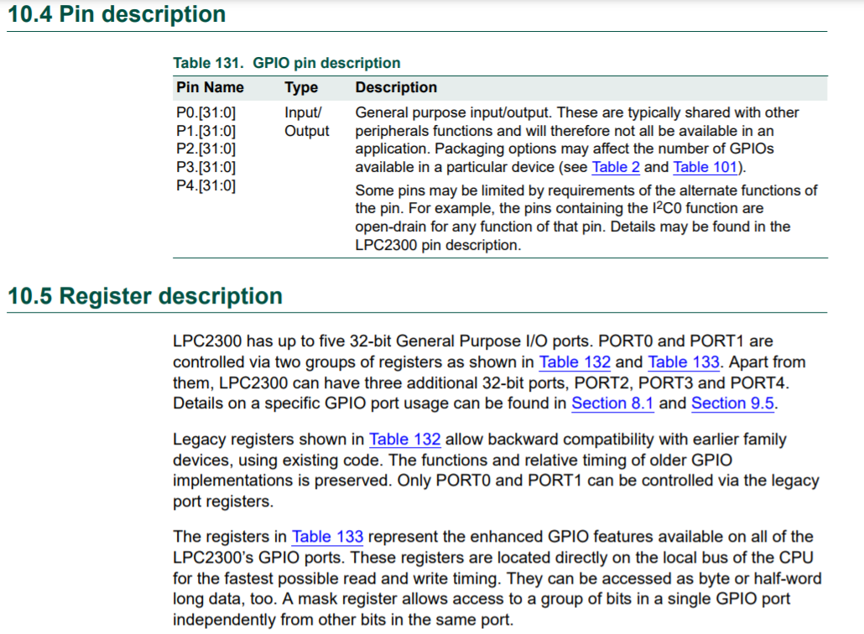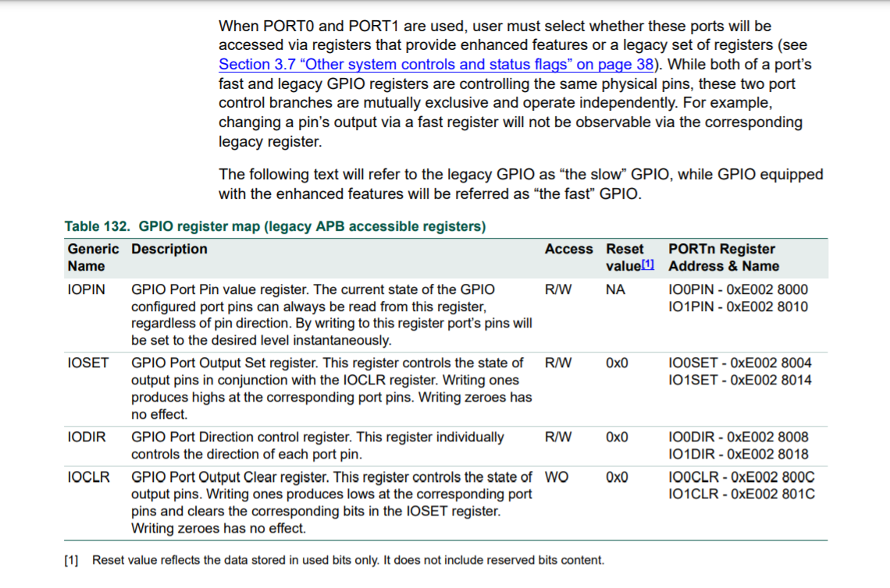

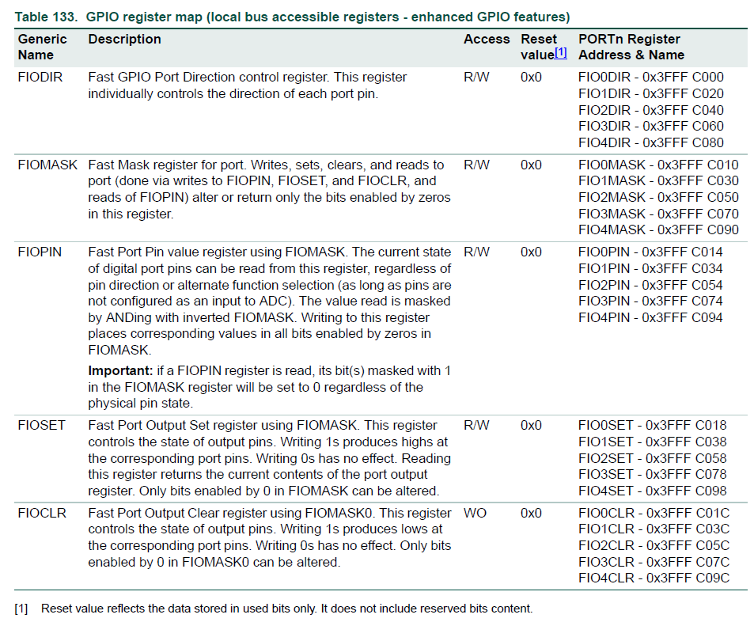

**FIOxDIR INSTRUCTION Instructions:**

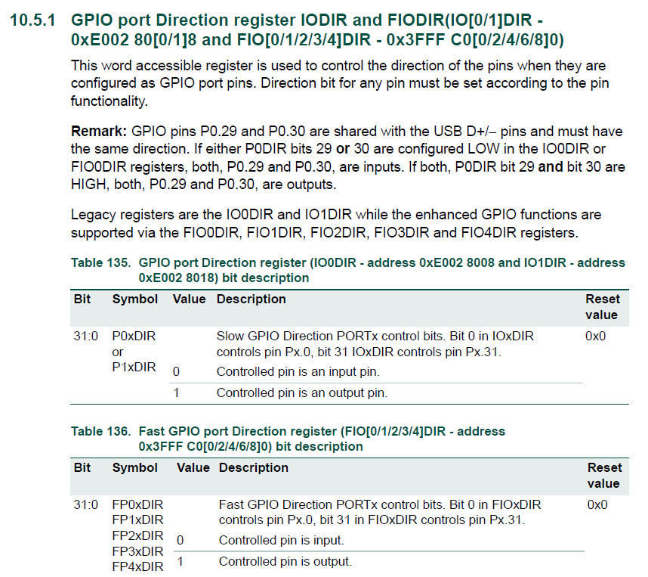

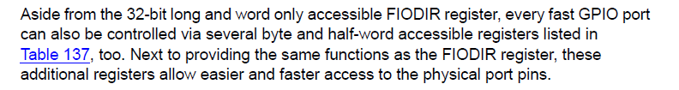

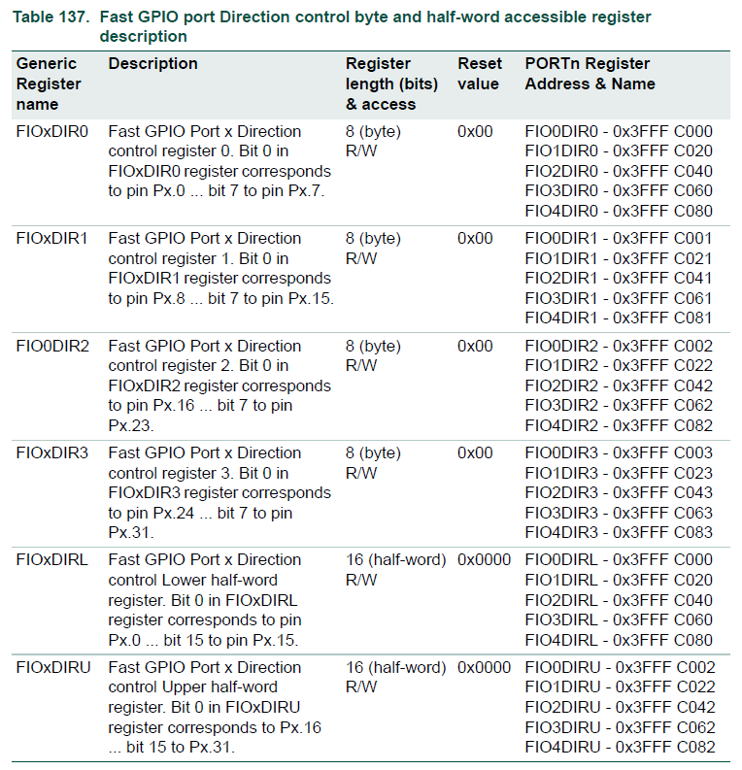

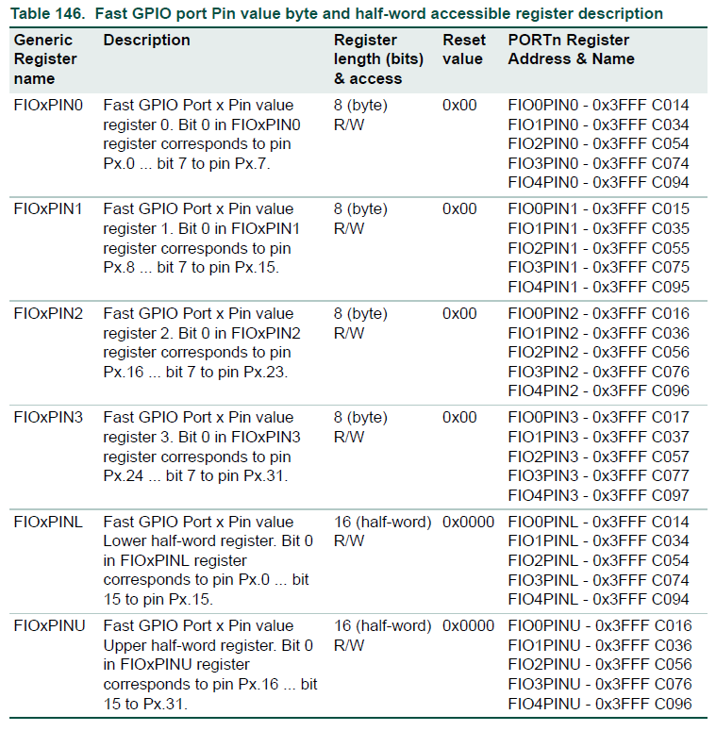

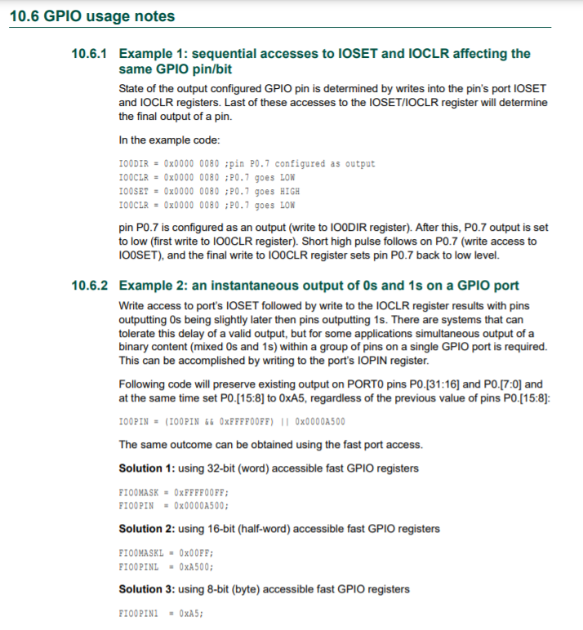

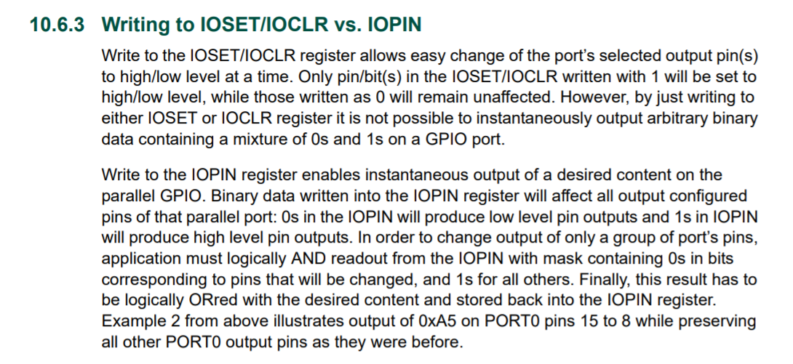

**STEPPER MOTOR:**

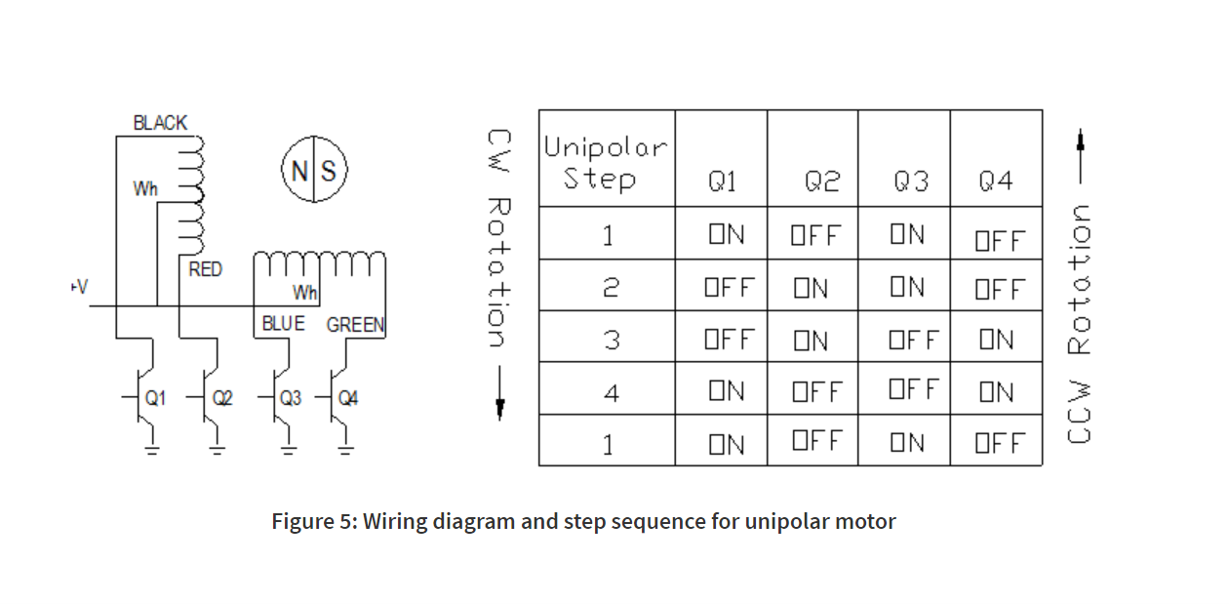

**Example program for first question:**